This Photo by Unknown Author is licensed under CC BY-SA
Challenge: Part 1:The team is to construct a maze that an Ozobot could maneuver through. You are making a maze for your competitors, so make it difficult, but still do-able! Make sure it has enough space for the Ozobot to move around/under.
Part 2: The team is to code their Ozobot through a competitor’s maze using Ozobot’s color codes.
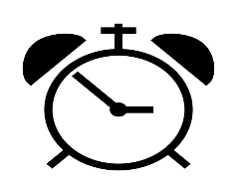
Time: You will have 15 minutes to use your teamwork, creativity and innovation skills to build a maze for your competitors. You will then have 10 minutes to use coding to create, test and refine a code that will get your Ozobot through a maze.
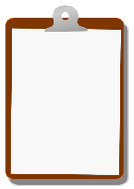
Setup: All materials to be used are placed on the table. The team will create a maze for their competitors to maneuver. Teams will move clockwise to a competitor’s maze and use coding to create, test and refine a code that will maneuver their Ozobot through the maze.

Procedure: During the first 15 minutes, you are to construct your maze. At the end of the 15 minutes, your maze must completely connect from the start to finish line. Your team should determine and label a start and finish line. During the next 10-minutes, you may not alter the maze. Using the code sheet and markers, your team will create a code to gets your Ozobot from ‘start’ to ‘finish’.
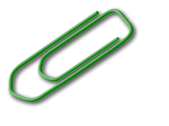
Materials
- 1 White piece of paper
- Legos
- Ozobot Markers
- 1 Ozobot
- Code Sheet

Scoring: 5 points if your Ozobot finishes the maze.

