Important Contributions to Electricity
Draw a line with a cool code connecting the important person to the picture that represents their discovery about electricity.
Use your Ozobot to read the line of code you created.

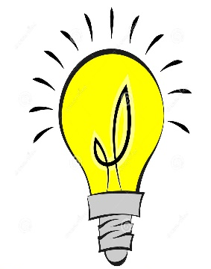
Thomas Edison

Michael Faraday

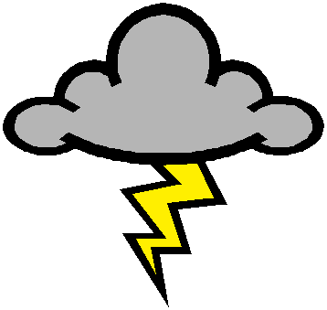
This Photo by Unknown Author is licensed under CC BY-SA-NC
Benjamin Franklin

Important Contributions to Electricity
Circle the correct person that is described by the statement. Enter the Ozo code that will take the robot to the correct answer to each question.
Thomas Edison
Michael Faraday
Benjamin Franklin

This inventor would be the
main person in the nonfiction book named
An Introduction to Light and Light Bulb

Thomas Edison
Michael Faraday
Benjamin Franklin

This inventor showed how electric current
in wires produce a magnetic field.

Thomas Edison
Michael Faraday
Benjamin Franklin

This inventor used a lightening rode to show
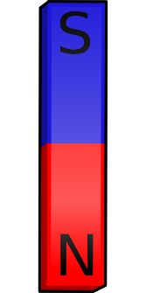
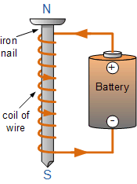
Electromagnets & Magnetism

When an electric current passes through a wire curled around an iron core this creates a/an _____________________.

Experiment!!
What do you observe about how tightly the wire is coiled around the nail? Is it coiled a few times or many? Do you think this makes the strength of the electromagnets greater or weaker?

Where is the magnetic field the strongest/greatest? Was it in the middle of the iron rod, at one end or the other, at both ends?

How is this electromagnet different than a regular magnet you’re used to? Can it be turned on and off? How do you turn it on and off?

What other observations have you made at this station?
Conductors and Insulators
Test each of the items in the box, using them as a switch to close this circuit. Do they conduct electricity well?
Use the chart below to organize the items in the box as a conductor or insulator after you’ve tested them. Write the name of each under either conductors or insulators.
Conductors | Insulators

that lightening is formed of electricity.

Series Circuit
Parallel Circuit
Open Switch
Closed Witch
Type of circuit that has a complete path that allows electricity to flow through it.
The type of circuit that has an incomplete path that allows electricity to flow through it.
A device that controls whether a circuit is open or closed

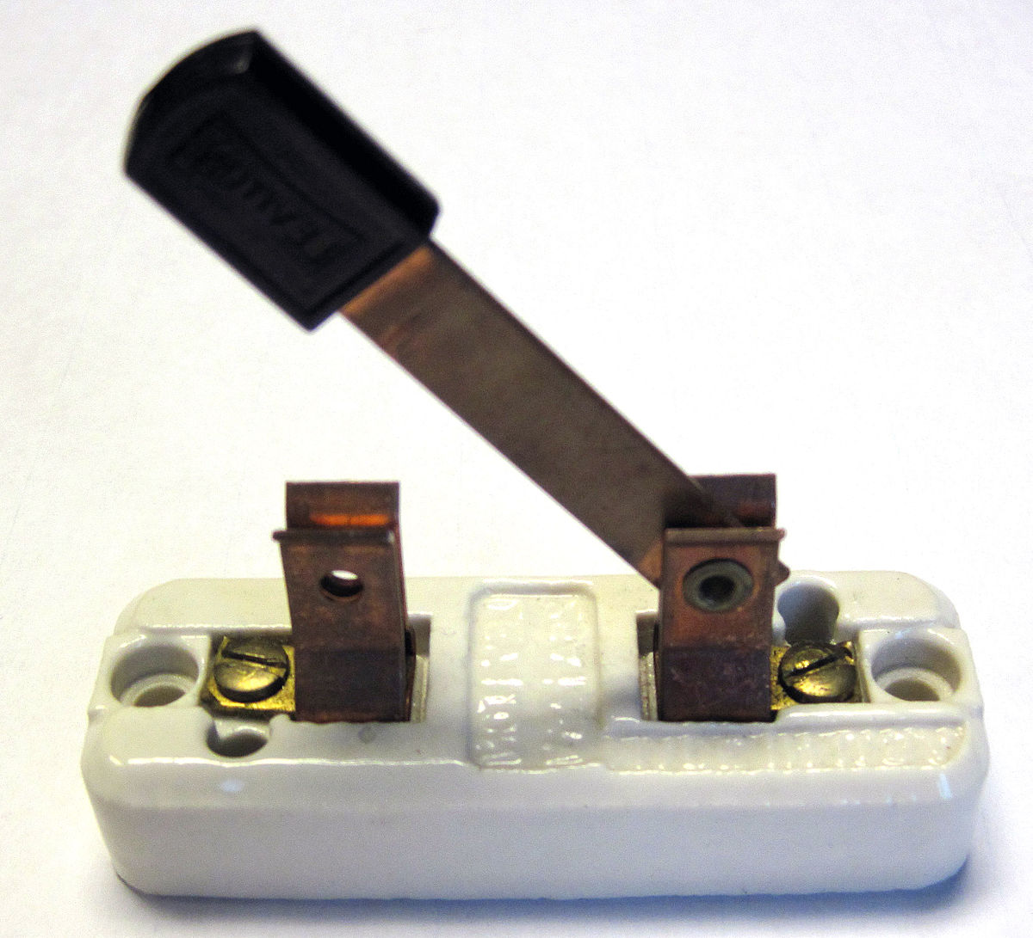

Test each of the items in the box, using them as a switch to close this circuit. Do they conduct electricity well?
Use the chart below to organize the items in the box as a conductor or insulator after you’ve tested them. Write the name of each under either conductors or insulators.
Conductors | Insulators

